# Safety, Warnings, & Limitation of Liability

1. Read this manual before using Leviathan. Failure to follow proper safety precautions in this manual can result in serious injury, death, or property damage. Keep this manual in a safe location for future reference.



1. Check all connections before use. Shipping increases the risk of connections coming loose. Ensure proper wiring procedures are followed. If anything seems unsafe, verify that you are correctly using the product.
2. As with any electrical device, take the following precautions:

* Avoid all contact with water. While Leviathan is meant for aquarium automation, that doesn’t mean it goes *in* the aquarium! If Leviathan comes in contact with water, it is recommended to turn off the circuit breaker for the outlet & then unplug Leviathan.
* Leviathan is rated for a maximum current draw of 10 amps. Refer to your equipment’s manufacturer’s instructions for current usage.

1. Under no circumstances shall Kickstarter, the project creator, or their affiliates, or partners, be liable for any indirect, incidental, consequential, special, or exemplary damages arising out of or in connection with your use or inability to use Leviathan or any related files or components. This limitation of liability shall apply whether or not the damages were foreseeable and whether or not anyone involved in the Leviathan project was advised of the possibility of such damages. This disclaimer applies to, but is not limited to, damage to property & persons. In no circumstances, shall the creator of Leviathan have an aggregate liability for any damages arising from use of Leviathan or its components greater than two (2) times the purchase price of the Leviathan components shipped to the user. The foregoing limitations will apply even if the above stated remedy fails of its intended purpose.
2. Leviathan documentation is for guidance only, not an absolute instruction manual. The purpose of this technical document is to supplement the Reef-Pi usage instructions found on adafruit.com. If anything seems incorrect, unclear, or unsafe, please contact Schreiber at the Reef2Reef forums before proceeding. Any action you take upon the information in this document is strictly at your own risk & no individual involved with Leviathan will be liable for any losses or damages in connection with the use of the documentation, whether due to errors, omissions, or misuse. The information contained in this document is provided on an “as-is” basis with no explicit guarantees of completeness or accuracy.

# Table of Contents

## Features

* 1. Equipment control
  2. Temperature Monitoring
  3. Light Dimming
  4. Dosing
  5. Float Switches
  6. Optical Sensors
  7. pH Probe

## Board Images & Labeling

## Peripheral Hardware

1. Sensors, Probes, & Switches
   * 1. Float switch
     2. Optical level sensor
     3. Temperature sensor
     4. pH probe
2. Electrical & Mechanical Control
3. Outlet Control (Relays)
4. Light dimming
5. Dosing
6. Power
7. 12V adapter
8. LM2596 buck converter
9. AC power cord
10. Power wire
11. Raspberry Pi & SD Card
12. Raspberry Pi
13. SD Card

## Adding Modules to Leviathan

1. Basic Principle & Initial Setup for All Modules
2. 12V power
   * + 1. 2.1mm barrel connector
       2. Wiring to LM2596 buck converters
       3. 12V DC power adapter
3. LM2596 buck converter(s)
4. Adjusting power output(s)
5. Wiring to board input(s)
6. Raspberry pi header pins
7. [Equipment Control (Relays)](#_Equipment_Control_(Relays))
8. Components required
9. Wiring from board to relays
10. Preparing your outlets
11. Wiring power input
12. Wiring from relays to power input
13. Wiring from relays to outlets
14. Installing your outlets
15. Temperature Monitoring
16. Components required
17. Populating the board
18. For populated board
19. Wiring the DS18B20 temperature probe(s)
20. Wiring the female 3.5mm connectors
21. Plugging in the DS18B20 temperature probe(s)
22. [Light Dimming](#_Light_Dimming_(Compatible) (*Compatible with lights that use a 10V PWM signal*)
23. Components required
24. Populating the board
25. For populated board
26. Wiring the LM2596 buck converter
27. Wiring the female 3.5mm jacks
28. Plugging in your lights (For lights with a 3.5mm jack that use 10V PWM control)
29. Lights without 3.5 jack
30. Dosing
31. Components required
32. Populating the board
33. For populated board
34. Wiring from leviathan to your dosing pump(s) connector
35. Connecting the wiring to your dosing Pumps
36. Connecting your dosing pumps to Leviathan
37. [Float Switch(es)](#_Float_Switch(es))
38. Components required
39. Populating the board
40. For populated board
41. Wiring the float switch(es)
42. Mounting the float switch(es)
43. [Optical Sensor(s)](#_Optical_Sensor(s))
44. Components required
45. Populating the board
46. For populated board
47. Wiring the optical sensor(s)
48. Mounting the optical level sensor(s)
49. pH Probe
50. Components required
51. Populating the board
52. For populated board
53. Wiring from the connector to the board
54. Addressing the pH probe

## Operation

1. Adding the Raspberry Pi
2. Downloading the files
3. Preparing your Micro SD Card
4. Powering
5. Interfacing
6. Setting up Wi-Fi
7. SSH Access (optional)
8. Setting up Reef-Pi
9. Accessing Reef-Pi for the first time
10. Configuring Reef-Pi
    * + 1. Default configuration
        2. Making changes to your configuration
        3. Dashboard
        4. Inlets, outlets, sensors, jacks, etc.
        5. Equipment
        6. Temperature
        7. Dosing
        8. Auto Top-Off (ATO)
        9. Lights
        10. Macros
        11. Timers
        12. Troubleshooting & additional resources
11. Using Reef Pi
    1. Equipment
    2. Temperature
    3. Dosing
    4. Auto Top-Off (ATO)
    5. Lights
    6. Macros
    7. Timers
    8. Troubleshooting & additional info

## Miscellaneous Notes

1. Current draw
2. pH Board & PCA9685 address
3. PWM 3 & 4

## Troubleshooting

## [Links (Updated manual, setup files, 3D printable files, etc.)](#_Links_(Updated_manual,)

# Definitions

|  |  |
| --- | --- |
| Leviathan | The blue circuit board with the Leviathan logo. This is the base for all the circuitry in your controller & eliminates the need for wiring to individual pins on the Raspberry Pi. |
| Module | Each separate job the Leviathan board can perform is considered a module. For example, if you are using your Leviathan for equipment control, temperature monitoring, & light dimming, you are using 3 modules. |
| Pad | Area of exposed metal on the surface of the Leviathan board. This is where connectors or components are soldered to. The Leviathan board has over 250 individual pads. |
| Center key | Male JST connectors have a small tab that slides into the slot on the female connectors. For orientation during wiring, this manual will refer to this tab as the center key. |
|  |  |
|  |  |

# Features

## Equipment control

1. Leviathan allows for up to 12 individual outlets to be controlled.
2. Control methods: On/off toggles on equipment screen, timers, custom user macros, parameter changes.
3. Equipment status can be viewed from the dashboard.

## Temperature Monitoring

* + Up to 3 separate temperature zones can be monitored.
  + Temperature readings are graphed & recorded.
  + Temperature thresholds can be set to perform actions such as turning heaters or chillers on/off, or to send alerts.

## Light Dimming

* + Lights using 10V PWM control can be set to dimming cycles.
  + Some lights, such as Kessil 360/160 allow for simple plug-ins with no modifications.
  + Other lights, such as Mars Aqua & many other “black box” lights require modification to access the dimming control.

## Dosing

* + Up to 2 separate dosing pumps may be controlled based on schedules.
  + Fine-tuned calibration allows for precise dosing & tweaks.

## Float Switches

* + Up to 2 separate float switches may be used to monitor water level & control equipment such as pumps for auto top-off.

## Optical Sensors

* + Up to 2 separate optical sensors may be used to monitor water level & control equipment such as pumps for auto top-off.

## pH Probe

* Using an isolated pH probe interface, fluctuations in pH can be monitored & tracked.

# Board Images & Labeling

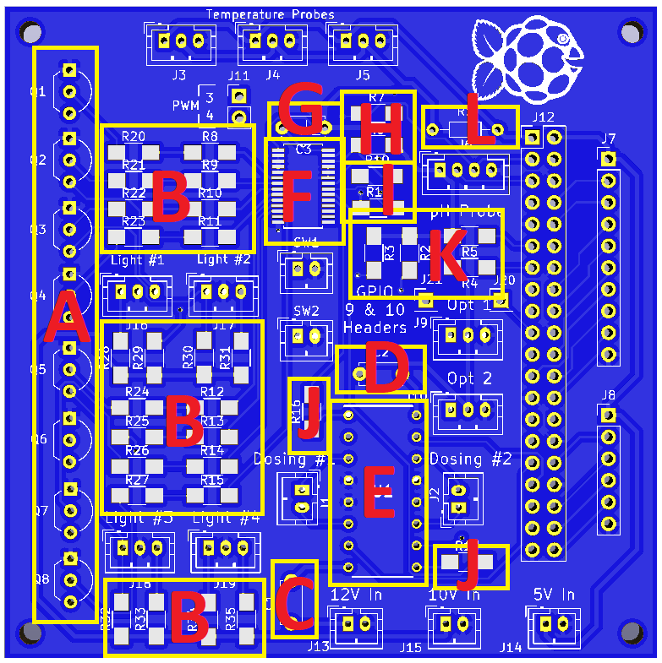

Figure 1-Component Locations

* A-Transistors for light dimming
* B-Resistors for light dimming
* C-12V smoothing capacitor for L293D
* D-5V smoothing capacitor for L293D
* E-L293D motor driver
* F-PCA9685pw LED driver
* G-5V smoothing capacitor for PCA9685pw
* H-Pull-up resistors for SCL & SDA inputs on PCA9685pw
* I-Resistors for PWM 3 & 4
* J-Resistors for PWM 1 & 2 (Used for EN 1,2 & EN 3,4 on L293D)
* K-Resistors for float switches
* L-Resistor for temperature monitoring

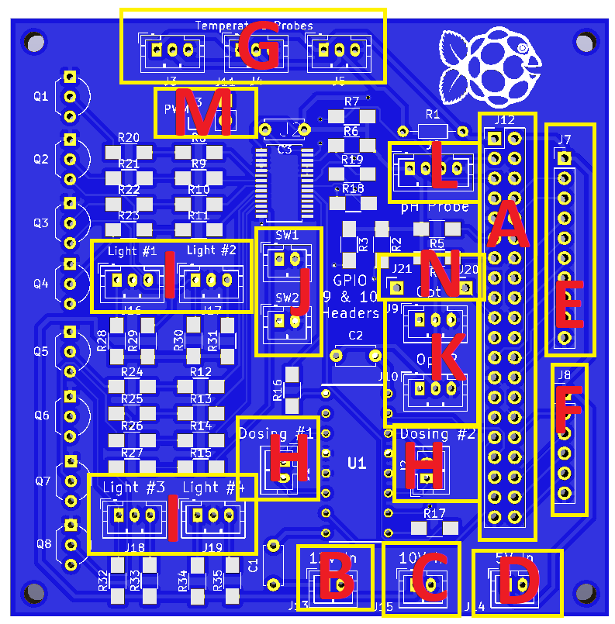

Figure 2-Connector Locations

* A-Raspberry Pi
* B-12V Power in from barrel jack
* C-10V power in from LM2596 buck converter
* D-5V power in from LM2596 buck converter
* E-8 relay board
* F-4 relay board
* G-DS18B20 temperature probes
* H-12V dosing pumps
* I-10V PWM light dimming
* J-Float switches
* K-Optical sensors
* L-pH probe
* M-PWM 3 & 4
* N-GPIO 9 & 10

# Peripheral Hardware

## Sensors, Probes, & Switches

* 1. Float switch
     + 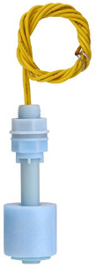Recommended float switches are DP5200 from Anndason. Other float switches may work, but all specific instructions in this document will be for the DP5200.
     + With the wires pointing upwards & the float allowed to rest at the bottom, switch is in the open state.
     + Installation in a sump for auto top-off use will let the float bob on top of the desired water level. When the float falls to a lower level, the switch will open, triggering the auto top-off pump.
     + Mounting brackets for the sensor can be 3-D printed from the .stl files in the float switch folder.
  2. Optical level sensor
     + 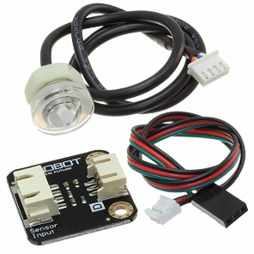Recommended optical level sensor is the Photoelectric Water / Liquid Level Sensor for Arduino from DFRobot.
     + The sensor is normally in a LOW logic state. When liquid comes in contact with the sensor, it outputs a HIGH logic signal.
     + Installation in a sump for auto top-off use will allow the tip of the sensor to touch the top of the desired water level. When the water level falls, the sensor will switch to LOW, triggering the auto top-off pump.
     + Mounting brackets for the sensor can be 3-D printed from the .stl files in the optical level sensor folder.
  3. 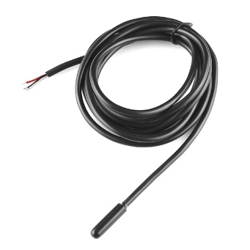Temperature sensor
     + Recommended temperature sensor is the Waterproof DS18B20 Digital Temperature Sensor.
     + To prevent corrosion, there are two options.
       1. A pre-sealed temperature sensor. This is the easier method, but at added cost.
       2. DIY sealing. This is slightly more time intensive, but can save $20+ depending on how many sensors used in your setup. For this, a 2-layer seal is recommended, but likely overkill. Simply apply enough heatshrink to cover the metal sheath & heat it to shrink. Next, dip the sensor in Plastidip & allow to dry. More layers may be applied if desired, but could negatively affect the responsiveness of the sensor.
       3. Mounting brackets for the sensor can be 3-D printed from the .stl files in the temperature sensor folder.
  4. pH probe
     + Recommended pH probe is the Pinpoint Marine Probe. Other double-junction probes should work. Refer to the Reef2Reef forum’s Reef-Pi thread to see what other people have used successfully.
     + pH probes are highly sensitive sensors that require calibration to ensure accuracy. Recommended method of calibration is to use 6.81 & 9.18 pH calibration solution powder.

## Electrical & Mechanical Control

1. 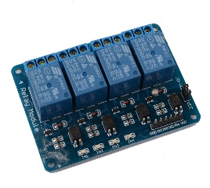Outlet Control (Relays)
   * + Rather than relying on an expensive, bulky, & separate 3rd party power strip, Leviathan uses relay boards that allow full customization of the number of outlets controlled.
     + 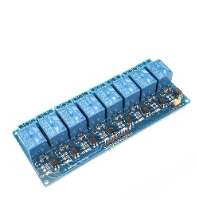The relay boards used may be any brand, as long as long as they are intended for 5V usage. Relay boards verified to work are Xiuxin, JBTek, & DAOKI.
     + Leviathan has the ability to control up to 12 individual relays, but any amount from 1-12 may be utilized. For full 12 outlet control, a 4 relay board & an 8 relay board are used.
     + Standard 120V 15A outlets are recommended for use in a Leviathan setup. As always for any equipment around water, powering a Leviathan setup with a GFCI outlet is recommended.
2. Light dimming
   * + [](https://www.banggood.com/ZMI-AL103-Braided-3_5mm-Jack-Audio-Cable-Gold-Plated-3_5-mm-Male-to-3_5mm-Male-Aux-Cable-for-Mobile-p-1273565.html)Light dimming as achieved using 10V PWM control. Not all lights use this method of control. Typically, lights with a 3.5mm audio jack meant for dimming control are compatible.
     + If your light does not have a 3.5mm connector, it still may be compatible, but require some modification, additional components, or adapters. Contact the light supplier to find out if your light uses 10V control for dimming.
     + Known compatible lights: Kessil A3650/A360WE, Kessil A160WE, & Mars Aqua.
3. Dosing
   * + 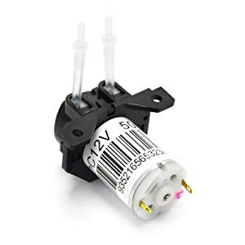Recommended dosing pump is the Gikfun 12V DC dosing pump, due to its low current requirements (80mA).
     + Other 12V peristaltic pumps may be used as desired, but ensure your current requirements do not exceed the available current your power supply can provide.

## Power

1. 12V Adapter

* A 12V DC power adapter rated for at least 2.5A is recommended for optimal performance of Leviathan with a Raspberry Pi running Reef-Pi. Power usage information can be found in section 9.1, Miscellaneous Notes.
* If you are confident you are using lower current, by using a lower power Raspberry Pi Zero W, or fewer modules, you may size your power supply accordingly.
* This document calls for a power supply with a 2.1mm plug. If you wish to use a different size, you may. Just change the size of the barrel connector to match.

1. LM2596 buck converter

* Adjustable LM2596 buck converters are the recommended source of 5V power used by Leviathan to power the Raspberry Pi & the 10V power used to control light dimming via PWM. Only one LM2596 is necessary if the light dimming module is not utilized.

1. AC power cord

* A standard AC power cord is required to power the outlets. Ensure the current rating for the cord matches or exceeds the current (Amps) being used by your equipment. Standard household circuits are typically rated for 15 or 20 Amps. If you are unsure of your power requirements, simply match the Amps your circuit breaker for the room your Leviathan will be powered in is rated for.

1. Power wire

* You will need wire to connect your outlets to power. It is best practice to match the current rating of your AC power cord. If unsure, 16-18 gauge wire should work, unless you are powering a device with higher than normal current draw. It is recommended, but not necessary, to use stranded wire to make wiring easier. The total length of wire needed will vary depending on the number of outlets you use. You will need 3 separate colors to differentiate power, neutral, & ground. In this document, Red will be used for power, white for neutral, & green for ground. However, you may use any color as long as you keep track.

## Raspberry Pi & SD Card

1. Raspberry Pi
   * It is recommended to use either the Raspberry Pi 3, 3B,+ or Raspberry Pi Zero W. Other Raspberry Pis will work, but I’ve only tested with these two (most common) models. Each model is discussed below.
   * Zero W
     1. Recommended for more advanced users that want to save some money that don’t mind tinkering with it.
     2. Not as powerful as the 3B+. Will run Reef Pi, but will load screens more slowly.
     3. Requires additional purchase of micro USB adapter & micro HDMI adapter, as this smaller board has smaller connections most mice, keyboards, & screens do not work with.
     4. You’ll either need a keyboard/mouse combo that runs off the same usb plug-in, or deal with switching back & forth between using the mouse or keyboard.
   * 3B or 3B+
     1. The 3B+ or 3B is recommend for anyone that doesn’t mind spending the extra $20 to avoid the need for workarounds & extra purchases.
     2. The 3B is virtually the same as the 3B+ for Leviathan’s purposes. If you can get it cheaper than the 3B+, it will work just as well.
     3. The 3B & 3B+ come with standard USB & HDMI ports, so no need to buy any additional adapters. Unless you already have the adapters, buying a 3B or 3B+ is likely the cheaper option.
2. SD Card
   * It is recommended to use a 16 GB or larger SD card.
   * You will have to format this SD card to FAT32 (discussed later in this document).

# Adding Modules to Leviathan

## Basic Principle & Initial Setup for All Modules

1. 12V power
2. 2.1mm barrel connector
   1. Wires will be soldered to the V+ & GND pins of the barrel connector to provide 12V power to different components in your setup.
   2. One set of wires (up to 3 sets of V+ & GND wires, total of 6 wires) will be needed for each of the following:
      1. 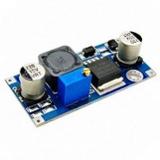5V buck converter. Every build needs a minimum of one set of 12V power wires connected to the buck converter that will be adjusted to 5V to power the Raspberry Pi.
      2. 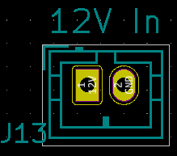Setups utilizing dosing pumps will require an additional set of V+ & GND wires coming from the barrel connector. These wires will be added to the 12V in connector at the bottom of the board. Wire the left, square pad to V+ & the right, circular pad to GND.
      3. Setups utilizing light dimming will require an additional set of V+ & GND wires coming from the barrel connector. These wires will be connected to a second buck converter that will be adjusted to 10V later.
   3. Solder the necessary amount of wires to the barrel connector. Use enough wire to reach their end point. If unsure of the needed length, it’s better to err on the side of longer. You can always cut wire off, but adding it on is much harder.
3. Wiring to LM2596 buck converters
   1. From the 2.1mm barrel jack, solder the V+ terminal to the In+ pad on the converter. Solder the GND terminal to the In- pad.
   2. Repeat this process for the second buck converter, if you are planning on using light dimming.
4. 12V DC power adapter
   1. **NOTE**-Do not touch or connect the Out+ & Out- pads on the buck converters, or any exposed metal/wiring in your current build.
   2. To test correct wiring of the jack & converters, plug the 12V power adapter into the wall. Plug the other end into the barrel connector.
   3. If wired correctly, the red LED light on the buck converter should turn on.
   4. If no LED comes on, verify the correct terminals were used, the adapter is plugged in, & the wires are fully connected.
5. LM2596 buck converter(s)
6. Adjusting power output(s)
   * + - 1. Follow the manufacturer’s instructions for adjusting the voltage down to your desired voltage.
         2. For typical adjustable buck converters, the small knob must be turned 10 or more times counter clockwise before the voltage will begin to drop.
         3. Use a standard voltmeter/multimeter to monitor the voltage output at the Out+ & Out- terminals
         4. Continue to adjust the voltage output down until your desired voltage.
         5. Every build needs at least one converter adjusted to 5V. The light dimming feature needs an additional 10V converter.
7. Wiring to board input(s)
   * + - 1. It is recommended to use JST-XH connectors or pin headers to connect components such as buck converters to Leviathan. You may solder directly to the board, but this options will reduce the ease of use.
         2. 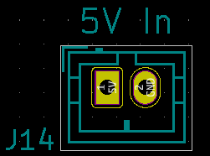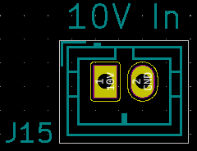From the buck converter adjusted to 5V, connect the Out+ pad to the left, square pad on 5V In (J14) & the Out- pad to the right, circular pad on 5V In.
         3. If using light dimming, from the buck converter adjusted to 10V, connect the Out+ pad to the left, square pad on 10V In (J15) & the Out- pad to the right, circular pad on 10V In.
8. Raspberry pi header pins
   * + 1. All build require header pins added in the large block of 40 pads on the right side of the board (section A in the Connector Locations image) to connect to the Raspberry Pi.
          1. It is recommended to use female header pins in these holes, in order to easily disconnect the Raspberry Pi if necessary.
          2. Insert the header pins into the board from the bottom. The metal pins should be the only part visible from the top of the board. The black section that has holes to plug more pins into should be on the side of the board with the large logo.
          3. Solder each of these pins to its pad, ensuring no “solder bridges” connect 2 or more pads together accidentally. If this occurs, simply reheat the solder & either wick/pump it away, or guide it onto a single pad/pin.
          4. You should now be able to plug in a Raspberry Pi into Leviathan. If the pin headers wound up crooked, they may need to be adjusted or re-soldered.

## Equipment Control (Relays)

1. Components required
   * + 1. Relay board(s)
          1. 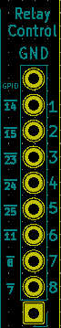At least 1 relay board with 1 relay module is required for equipment control. The maximum relays under normal configuration is 12 spread across 2 boards-a 4 relay board & an 8 relay board.
       2. Female to Male or Female jumper wires
          1. One end of your jumper wires should be female to connect to your relay board. The other end will be soldered directly to the board.
       3. Outlets
          1. 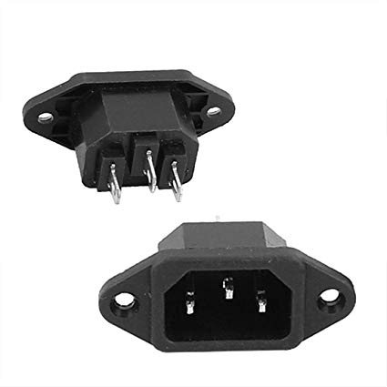Standard 120V 10 or 15 A outlets are needed. One outlet will be controlled by 1 relay output, match the number of relay outputs to your desired outlets (max of 12).
       4. C14 panel mount plug
          1. This is the typical plug you see on most computers & TVs.
          2. This will be the connection point for your 120V power coming from the wall to power your outlets.
          3. 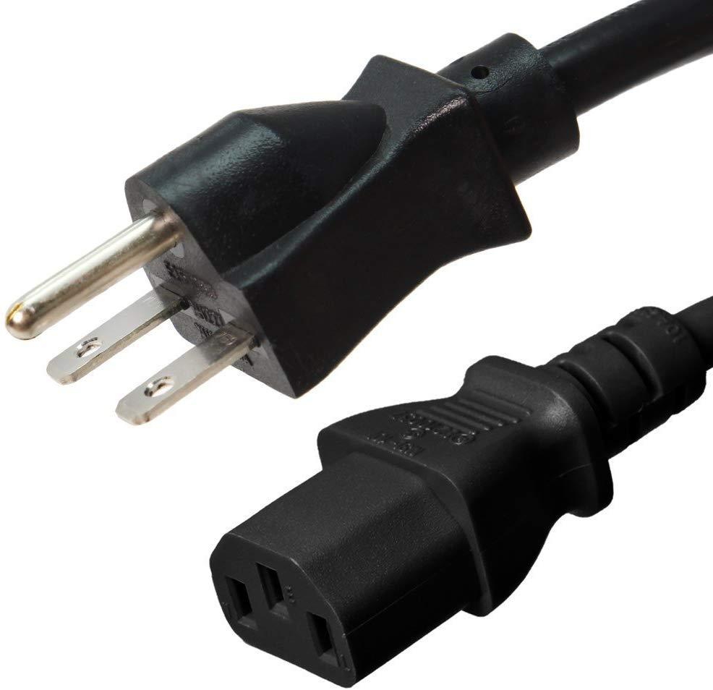If you are using one of the standard Leviathan enclosures & you are purchasing your own plug, ensure its dimensions are (include acceptable dimensions).
       5. C13 power cord
          1. This is the typical power cord you see for most computers & TVs.
          2. Ensure it is rated for at least 10A, 15A is recommended.
       6. Wiring
          1. You will need the following 16-18 gauge wires:

Power wire-I prefer red wire, but you may use any color as long as you make note of it.

Neutral wire-I prefer white wire, but you may use any color as long as you make note of it.

Ground wire-I prefer green wire, but you may use any color as long as you make note of it.

* + - * 1. You will also need small-gauge (20-24) wire, or standard “breadboard jumper” wires to connect your relays to Leviathan.

Options of connectors for your wire.

If you are using JST-XH connectors (Not recommended due to the large amount of connections), simply use 24 gauge stranded wire & attach your pins & connectors.

If you are using pin headers, simply use female-female breadboard jumper wires. Or, to make your own, crimp on a female 2.5 mm pin connector to each wire so they can attach to the male header pins. It’s *much* easier to just buy them pre-made!

If you are soldering directly to the board, you will still need a female 2.5mm pin connector on one end to connect to the relay board.

Recommendation for connectors

The easiest method of connecting your relays to Leviathan is the use of Female-Female breadboard jumper pins.

This method only requires you to solder male header pins to Leviathan in section E, F, or both, of the Connector Locations image, depending on how many outlets you plan to control. You will need one relay for each plug-in on your outlets.

1. Wiring from board to relays
   * + 1. NOTE-It doesn’t matter whether you use the top (10 hole) or bottom set (6 hole) of relay holes for your relay board connection. All that matters is you connect 5V (square pad) from the board to the 5V pin on the relay board & the GND (top round pad for both sets of holes) to the GND pin on the relay board.
       2. The numbers to the left of the holes correspond to their GPIO number. The number to the right of the holes correspond to their relay IN connection. For example, the top-most relay connection is GND, the second top-most hole is connected to GPIO 14 of the Raspberry Pi & will connect to pin #1 on the relay board.
       3. It is recommended to wire the pads to the relay board pins in order, to make configuration easier. However, they may be connected in any order desired.
       4. Use whichever method discussed above in the Components Required section to connect your relays. Female to female breadboard jumpers are recommended.
2. Preparing your outlets
   * + 1. Nearly all outlet terminals come connected by a tab. This tab shares connectivity between the two outlets. However, in order to individually control each outlet, the power tab must be removed. \**If you prefer to have connected outlets (for example, two heaters plugged into each of the outlets you can control via the same relay), you may leave them connected & skip to “Wiring from relays to outlets”. However, make a note of this to save yourself a lot of troubleshooting later.*
       2. Locate the tab connecting your power terminals. Refer to your specific outlet’s manufacturer’s manual to identify the correct terminals.
       3. For many US outlets, the power terminals are brass, while the common/neutral terminals are silver. Again, refer to your specific outlet’s manual.
       4. Snap off the tab connecting the two power terminals together (*not the neutral ones*!). This can be done with a pair of pliers. Just grab the tab & leverage it back & forth until it separates.
       5. Ensure no metal remains touching between the two terminals.
       6. Now you have two individually powered outlets that can be controlled via your relay boards.
       7. For ease of wiring, it is highly recommended to prepare your neutral & ground connections to the outlets prior to wiring their power connections.
       8. Using your white (or whatever color you’ve selected for neutral power connections) wire, cut multiple sections of approximately 4-5 inches. You will need one wire between each of your outlets. (One outlet= 2 plug ins on the same body).
       9. The neutral tabs on your outlets should still be connected. If you accidentally removed them, you’ll have to connect each terminal together individually…or just buy new outlets, they’re cheap!
       10. \***Note**\* If you are using 2 rows of outlets, you may need a slightly longer jumper between one of the top row & bottom row outlets. The jumper wire between the two rows should be added by threading it under the divider between the two rows. (I highly recommend watching the instructional video for this section to see how to do this… hard to word, easy to demonstrate.)
       11. Strip approximately ½ inch of the wire jacketing off both ends of each of your white wires.
       12. Add a white wire to either neutral terminal of your first outlet & secure it (different outlets use different methods, typically screws).
       13. You will be left with one unused end of that wire hanging off of the outlet. Connect it to the next outlet on one of the neutral terminals.
       14. Take your next white wire, add it to the other neutral terminal of the second outlet.
       15. Attach the loose end of this wire to your third outlet.
       16. Continue this process until you have one white wire connecting each outlet.
       17. Now you will do something similar for green (ground) wires.
       18. Most outlets only have one ground terminal, typically indicated by a green color. You will be required to attach both the “in” & “out” jumper to the same terminal.
       19. Cut the same number & length of green wires as white wires & strip approximately ½ inch off each end.
       20. Attach your first green wire to the first outlet’s ground terminal.
       21. Attach *both* the second end of this first wire & one end of your second wire to your second outlet’s ground terminal.
       22. Repeat this process until you have one green wire connecting each outlet (leaving the wire between the two rows for last, to thread under the row divider, if applicable).
3. Wiring power input
   * + 1. The power input will require 3 different wires-Line (power), neutral, & ground.
       2. The power wire will be connected to your common terminals of the relays, while the neutral & ground wires will be connected directly to your outlets.
       3. If you have two relays, you’ll need two power wires leading off of your power input’s line terminal.
       4. Use enough wire to have slack, so you can still move & rotate the enclosure. If you are unsure of the length you need, 8 inches is typically a safe starting point- use more or less based on your enclosure size.
       5. Solder your power wire(s) to your Line terminal, typically labelled with an “L”-refer to your specific input’s documentation.
       6. Solder you neutral wire to your Neutral terminal, typically labelled with an “N” or a “C”.
       7. Solder your ground wire to your Ground terminal, typically labelled “G” or with a ground symbol (3 horizontal lines & a vertical line).
       8. Push these wires through your enclosure, so they’re inside.
       9. Screw your input into place.
       10. All these wires will be connected in later sections.
4. Wiring from relays to power input-Update to reflect input
   * + 1. The relays act as switches that will connect or disconnect your outlets from power. **NOTE**: Never touch any exposed wire or metal that is powered. Perform all wiring with the power cord unplugged from your power source.
       2. There are two options for splitting out power to each of the relays: Jumpers between each common terminal, or splitting the power terminal’s power wire into as many outputs as outlets you plan to power. The jumper method is generally easier & uses less wire, but may be difficult for relay boards with smaller terminals or if you’re using larger gauge wire.
       3. Splitting the power wire into multiple lines requires a bus bar. Both methods will be covered. In both methods, it is critical to ensure secure connection to the terminals to prevent a live power wire coming loose.
       4. **Jumper method**-While this is the cheapest method, requiring no additional purchase, it is worth nothing not all relay boards are the same quality. If you trust the terminals on your board to securely hold two wires, you may simply use small segments of wire to connect each common terminal to power. These jumper wires will carry power to each of your relays. The relays will then control when the power is provided to the connected outlets.
       5. From your power input, wire the power line to the first relay’s common terminal, or the right terminal of the first relay for non-configurable relay boards.
       6. Take a small section of your wire, approximately 2-3”, & strip a small amount of jacketing off of both ends. Just enough to expose enough wire to make full contact with the inside of your terminal. Typically about a quarter of an inch.
       7. Take one end of the short jumper wire & place it in the terminal with the power line. Now, tighten this terminal & give both wires a pull to ensure they do not come out. If either is loose or comes out, unscrew the terminal & place the wires back in.
       8. Now place the remaining end of the jumper wire into the next relay’s common terminal, or right terminal for non-configurable relays.
       9. Add a second jumper wire in this second common/right terminal & tighten. Pull each wire to ensure they do not come out.
       10. Repeat this process, connecting each common/right terminal until all relays on your board have their common/right terminal connected to power via jumpers. The last relay in the chain will only have one wire, as there are no relays left to jump to.
       11. *Optional-If your build will contain always on outlets that are not connected to a relay for control, it is recommended to add an 8” or longer jumper wire to the last relay in order to provide power to these normally on outlets. More on this in “Installing your outlets”, section vii below.
       12. If you have 2 relays, repeat steps e-j above using the second power wire from your power input.
       13. **Bus method**- A terminal block / bus bar may be used to split power to each outlet, rather than using jumpers. This method is 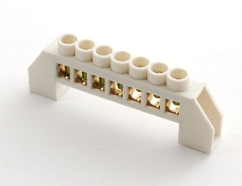slightly easier, but will be more expensive & messier, due to the extra wiring & purchase of the bus bar.
       14. You will need a bus bar/terminal block with enough terminals to cover each plug you plan on using, plus one. (Example: Your build has 8 different plugs. You need a bus bar/terminal block with at least 9 terminals. 1 for power input from the wall & 8 to wire power to the individual plugs.)
       15. There are many configurations of bus bars. Follow the instructions for your bus bar in order to split the power out to multiple terminals.
       16. 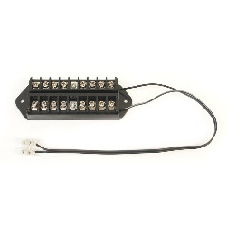Typically, all terminals on a power distribution bus bar are connected, so it does not matter which terminals you connect your power wires to. Refer to your specific bus bar’s documentation for hookup instructions.
       17. From your power input, wire the power line to the bus bar in the appropriate terminal (as all terminals are typically connected, it generally does not matter which you choose, but refer to your bus bar’s documentation).
       18. Now add power wire from the remaining terminals on the bus bar to each of the relay’s common (center) terminal, or the right terminal of each relay for non-configurable two-terminal relay boards.
5. Wiring from relays to outlets
   * + 1. Follow manufacturer’s directions for wiring relays to outlets. The following instructions may not be suitable for every make & model of relay board.
       2. If your relays only have two terminals each, you may skip to step f & ignore any mentions of NC/NO configurations.
       3. For many types of relay boards, wiring can be performed in two configurations-normally open or normally closed. If no power is applied to the relay board, a normally open configuration will result in the connected outlet being disconnected from power, while a normally closed configuration will result in the connected outlet remaining powered. It is up to you which wiring configuration works best; a mix of configurations for different outlets may be used, but keep note of which wiring configuration you used for each relay.
       4. 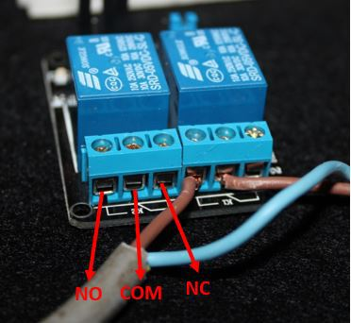If a piece of equipment remaining on is critical to the aquarium’s health, such as a heater, it is recommended to wire its relay normally closed. However, if a piece of equipment unexpectedly turning on may be harmful, such as an auto top-off pump, it is recommended to wire its relay normally open.
       5. An optionally NO/NC relay board will have an image near its terminals like the black symbol to the left. Wiring the top & center terminals will result in a normally open (NO) configuration & wiring the center & right terminals will result in a normally closed (NC) configuration. Take note of the picture showing the center & right terminals connected by the slanted line. Your relay board may be different. The safest guide to follow is the image on your board. If two terminals are connected, they are Normally closed. If they are not connected, they are normally open. Think of the center, slanted line as a switch-When no power is sent to the board, it’s in the state of the image. When power is sent to the board, it flips to the other terminal.
       6. Whichever configuration you choose, add a length of wire to your NC/NO terminal (or the left terminal for non-configurable relay boards) long enough to extend approximately 2-3” outside of the top of your enlcolsure. This is to ensure you have enough wire to secure to the outlet & to manuever them around during your installation of other modules.
6. Installing your outlets
   * + 1. \***Note**\* It is highly recommended to perform this section’s steps when you are ready to seal your enclosure. If you do this too early, the top of your enclosure will be inaccessible, forcing you to do all your connections from the bottom. Possible, but annoying.
       2. *Note* it is highly recommended to watch the instructional video for this section to ensure you have everything wired correctly.
       3. Feed the power wires from your relays up through the top of your enclosure.
       4. In the following step, make note of which relays you connect to which plug. This will be important later when configuring your equipment in the software. Personally, I prefer to wire them in order like you’re reading a book. Relay 1 to the top left plug, Relay 2 to the next plug to the right, etc. until you reach the end of a row. Then start with the next row left to right, until you run out of plugs.
       5. Refer to your outlet’s instructions to ensure correct connection terminal is used for power. The outlets I use have a brass terminal for power, but that is likely not standard for every outlet.
       6. Attach one relay’s power wire to one plug’s power terminal & secure it. Repeat this until every controlled outlet has a power wire.
       7. After all the controlled outlets are wired from the relays, if you have any non-controlled outlets, wire the 8” jumper from your last relay to the first non-controlled plug’s power terminal. From that terminal, add jumper between each non-controlled plug’s power terminals until every terminal in your setup has a power wire connected to it.
       8. Once securing all the power wires, you can now add the neutral & ground wires coming from your power input.
       9. Since you have all the outlets connected together across jumpers (from section iii. Preparing your outlets), you only need to connect your neutral & ground wires coming from out power input to one outlet.
       10. Connect the neutral wire from your power input to one of your outlet’s neutral terminals.
       11. Connect the ground wire from your power input to one of our outlet’s ground terminals.
       12. Once all wiring is secured, you can new install the outlets in your enclosure by screwing them into place.

## Temperature Monitoring

1. Components required
   * + 1. DS18B20 Temperature Sensor(s)
          1. Up to 3 separate sensors may be used.
       2. 3-pin JST-XH connectors (optional)
          1. 2.5mm JST-XH connectors are recommended to connect the sensors to the board.
          2. You may use pin headers & jumpers in their place, or solder directly to the board if desired.
       3. 4.7k THT resistor
          1. This is the only THT resistor in the build. THT resistors are the “typical” breadboard resistors with two wire leads that go through the holes on the board.
       4. TRS 3.5mm male & female connectors
          1. TRS connectors use 3 conductors: A tip, ring, & sleeve. Ensure your connector has 3 different tabs to solder to.
          2. For every temperature probe you wish to use, you’ll need a female 3.5mm connector. It will be wired directly to Leviathan allowing for easy installation of the temperature probe.
          3. For every temperature probe you wish to use, you’ll need a male TRS 3.5mm connector. It will be soldered to the wiring on the temperature sensor & plugged into to the female connector.
     1. Populating the board
        1. Adding connectors
           1. Connectors for the temperature sensors go on the top of the board (section G in the Connector Locations image).
           2. Simply solder on the same number or 3 pin header sets or 3-pin JST connectors as sensors you plan on using, matching the footprint printed on the board.
        2. Adding resistor
           1. Only one 4.7k THT resistor is needed, no matter how many temperature probes you plan to use.
           2. The holes to solder the resistor to are located on the top-right of the board, section L in the Component Locations image.
           3. Solder the resistor into the two holes marked on the board in this area.
     2. For populated board
        1. Wiring the DS18B20 temperature probe(s)
           1. Adding male 3.5mm connector

With the top of the male 3.5mm connector pointed upward & the longest terminal behind (see picture), the left terminal is for the 3.3V power, the long, center terminal is ground, & the right terminal is for the data connection.

Solder the red wire of the temperature probe to the left, power terminal.

Solder the black wire of the temperature probe to the long, center terminal.

Solder the yellow wire of the temperature probe to the right terminal.

* + - * 1. Additional waterproofing (optional, recommended)

While the DS18B20 temperature probes are marketed as waterproof, to ensure they are protected, it is recommended to take additional steps to further shield them.

Multiple methods can be used, no method is guaranteed to totally protect the probe, just further protect them compared to the manufacturer’s waterproofing.

The following methods have been

100% silicone can be applied in a layer around the probe. Allow to dry before placing in water.

Heatshrink can be applied around the probe & heated to shrink around it. It is recommended to apply silicone before this step. The excess silicone will leak out of the ends & seal them.

Plastidip needs to be tested

* + - 1. Wiring the female 3.5mm jacks
         1. When measuring & cutting the wiring to the jacks, leave enough wire to span from the board connection to your enclosure’s temperature probe jack holes.
         2. It is recommended to use black, red, & yellow wires to match the wiring of the temperature probe, but not required. The following instructions will refer to the wires as these colors. Substitute your wire color in place of the specific color called for if desired.
         3. Wiring to the female audio jack will be the same as the male: red to the left terminal, black to the center terminal, & yellow to the right terminal.
         4. If you are using the JST connectors on the board, crimp your pins onto the end of each wire. With the center key pointed upwards, install them in a connector in the following order from the left: red, yellow, black. You may now plug the connector into the board.
         5. If not using JST connectors, connect the red wire to the leftmost pad of the first temperature probe connection, the yellow wire to the center pad of the first probe connection, & the black wire to the third (rightmost) pad of the first probe connection.
         6. Repeat the above steps for any additional probes.
      2. Plugging in the DS18B20 temperature probes
         1. Ensure Leviathan has no power, either by unplugging the power supply entirely, or setting the power switch to the off position.
         2. You may now plug in all the temperature probes you plan on using.
         3. Once probes are plugged in, power may be restored to Leviathan.

## Light Dimming (Compatible with lights that use a 10V PWM signal)

1. Components required
   * + 1. TRS 3.5mm female connectors
          1. TRS connectors use 3 conductors: A tip, ring, & sleeve. Ensure your connector has 3 different tabs to solder to.
          2. For every light you wish to control, you’ll need a female 3.5mm connector. It will be wired directly to Leviathan allowing for easy installation of the light control wiring.
       2. LM2596 buck converter
          1. In addition to the buck converter adjusted to 5V to power the raspberry pi, an additional buck converter adjusted to 10V will be required to power the LED control circuit.
          2. Leviathan utilizes this 10V source & outputs an adjustable PWM signal to control lights that use 10V PWM control.
       3. TRS (Aux/audio/headphone/etc.) Wires/cables to lights
          1. Rather than soldering your own connectors onto generic wires, it is recommended to use standard 3.5mm audio cable with 2 male ends.
          2. One end will plug into the jack on your lights & the other will plug into the female connector wired to Leviathan.
       4. 3-pin JST-XH connectors (optional)
          1. 2.5mm JST-XH connectors are recommended to connect the 3.5mm jacks to the board.
          2. You may use pin headers & jumpers in their place, or solder directly to the board if desired.
       5. 9685pw, 118 LED driver
          1. This integrated circuit is used to output the 10V PWM signal used to dim or brighten the LEDs.
          2. It is critical to ensure the pins are soldered to the correct pads. There are multiple tutorials on surface mount soldering of fine-pitch components online that may be useful if you are not experienced with this sort of soldering.
       6. 1206 surface mount (SMT) resistors
          1. 10k ohm, 1k ohm, & 220 ohm resistors will all be utilized in the light dimming feature.
          2. Each component (intensity & spectrum) of each lighting channel uses 1 of each resistor.
          3. For a full build utilizing 4 lighting channels, 24 resistors total will be needed: 8x 220 ohm, 8x 1k ohm, & 8x 10k ohm.
       7. NPN transistors
          1. All transistors used are PN2222 NPN bipolar transistors.
          2. Leviathan has holes & footprint markings designed for the TO-92 transistor body type.
          3. For proper operation, ensure your transistors are rated to withstand at minimum 10V & 1A.
       8. 0.1 uF capacitor (optional)
          1. A small, ceramic capacitor is used to decouple the PCA9685pw & remove any noise or fluctuations on the power signal.
          2. If you are unconcerned about noise on the signal, you may simply omit the capacitor. If you choose to omit the capacitor & have issues controlling your lights, it may be beneficial to add the capacitor.
     1. Populating the board
        1. Adding connectors
           1. Connectors for the lighting control jacks go in the bottom & center left sections of the board (Section I in the Connector Locations image).
           2. Simply solder on the same number of 3 pin header sets or 3-pin JST connectors as sensors you plan on using, matching the footprint printed on the board.
        2. Adding components
           1. Note on components

Leviathan supports up to 4 independent lighting channels.

If you plan on utilizing fewer than 4 channels, you do not have to use all 24 resistors & 8 transistors.

As a general rule, Lights #1-#4 use the resistors & transistors in order from top to bottom or left to right, 2 rows for each light channel.

For example, Light #1 uses the 2 top most transistors, the two top rows of 10k/220 resistors, & the top left 1k resistors.

* + - * 1. Adding resistors

Each lighting channel you wish to control utilizes 6 resistors. (2x 220 ohm, 2x 1k ohm, & 2x 10k ohm).

All light control resistors are located on the left side of the board, in section B of the Component Location image.

Add the resistors in the appropriate spots, following the printed values in their footprints.

10k resistors are the leftmost, horizontal resistors.

1k resistors are the vertical resistors under the light connectors.

220 resistors are the resistors directly to the right of the 10k resistors.

* + - * 1. Adding transistors

Each lighting channel you wish to control utilizes 2 transistors.

Line the transistors up with the footprints on the left-most side of the board.

Flat edge of the transistor will face the edge of the board.

Place the leads from the transistor into the holes in the board, then solder into place.

* + - * 1. Adding the PCA9685pw

Solder the PCA9685pw to Leviathan (section F in the Component Locations image), with the small dot on the top of the chip pointed towards the top of Leviathan.

It is highly recommended to check that none of the pins are connected to each other by any stray solder by visual inspection & using a multimeter.

* + - * 1. Adding the 0.1uF capacitor (optional)

Simply solder the capacitor into the holes directly above the PCA9685pw. Orientation does not matter.

* + 1. For populated board
       1. Wiring the LM2596 buck converter
          1. You should already have a 10V buck converter connected. If not, refer back to section 7.1.ii, ignoring the notes about the 5V buck converter.
          2. At the end of 7.1.ii, you should have 2 buck converters connected to Leviathan-a 5V one to power the Raspberry Pi & sensors, as well as a 10V one to power the light dimming control.
       2. Wiring the female 3.5mm jacks
          1. When measuring & cutting the wiring to the jacks, leave enough wire to span from the board connection to your enclosure’s light control jack holes.
          2. The following instructions will refer to the wire colors as black, green, & blue. Substitute your wire color in place of the specific color called for if desired.
          3. With the long, middle terminal pointed downward, solder your blue wire to the left terminal, black wire to the middle terminal, & green wire to the right terminal.
          4. If you are using the JST connectors on the board, crimp your pins onto the end of each wire. With the center key pointed upwards, install them in a connector in the following order from the left: blue, black, green. You may now plug the connector into the board.
          5. If not using JST connectors, connect the blue wire to the leftmost pad of the first light channel connection, the black wire to the center pad of the first light channel connection, & the green wire to the third (rightmost) pad of the first light channel connection.
          6. Repeat the above steps for any additional light channels, up to 4.
       3. Plugging in your lights (For lights with a 3.5mm jack that use 10V PWM control)
          1. Ensure Leviathan has no power, either by unplugging the power supply entirely, or setting the power switch to the off position.
          2. Ensure your light has no power, either by unplugging its power cord entirely, or setting its power control to the off position.
          3. You may now plug in your 3.5mm (aux/audio) cord into your light & the 3.5mm jack connection for light control
          4. Repeat this process for each light channel you wish to control.
          5. Once 3.5mm cords are plugged in, power may be restored to Leviathan & the lights.
       4. Lights without 3.5mm jack & 10V PWM control
          1. If your light does not come pre-equipped with the connection necessary to control it, you may still be able to use it. There are too many lights on the market to cover in this documentation. Just search for your light’s name + 10V PWM control & if it’s compatible, you should find guides online.

## Dosing

1. Components required
   * + 1. 12V Dosing Pump(s)
          1. Up to 2 dosing pumps may be controlled using Leviathan.
       2. Silicone tubing
          1. If using the recommended dosing pump, 1/8 inner diameter silicone tubing is the best fit.
          2. Use as much tubing as necessary to reach your tank & dosing chemical containers from where you will be keeping your pumps.
       3. Wires/cables to pump(s)
          1. The size & type of wire used for connecting to your dosing depends on the distance you will need to run.
          2. In most circumstances, standard low voltage 24 gauge cable should be sufficient. (This is the common red/black cable that allows you to pull apart the red/black wires.)
       4. Spade connector/heat shrink+solder
          1. It is strongly recommended to secure your cable connection to the pump using either a spade connector, or a combination of solder+ heat shrink.
       5. 2-pin JST-XH connectors (optional)
          1. 2.5mm JST-XH connectors are recommended to connect the 3.5mm jacks to the board.
          2. You may use pin headers & jumpers in their place, or solder directly to the board if desired.
       6. L293D stepper motor driver
          1. This integrated circuit is used to output the 0-12V signal used to control the speed of the dosing pumps
       7. 0.1 uF capacitors (optional)
          1. Two small, ceramic capacitor are used to decouple the L293D & remove any noise or fluctuations on the power signal-one for 5V power & the other for 12V power.
          2. If you are unconcerned about noise on the signal, you may simply omit the capacitor. If you choose to omit the capacitor & have issues controlling your dosing pump speed, it may be beneficial to add the capacitors.
       8. *TRRS* 3.5mm female & male connectors
          1. TRRS connectors use 4 conductors: A tip, ring, a 2nd ring, & a sleeve. Ensure your connector has 4 different tabs to solder to.
          2. For every dosing pump you wish to control, you’ll need 2 solder points on your jack. If you plan on using only 1 pump, you can use a standard TRS or even a 2 conductor connector, but you will need to modify your Leviathan enclosure to fit these.
          3. Whether you plan on using 1 or 2 pumps, you’ll only need 1 male TRRS 3.5mm connector. It will be soldered to the wiring from the pumps & plugged into to the female connector.
          4. Match your connectors (Use TRS male with TRS female, or TRRS male with TRRS female).
     1. Populating the board
        1. Adding connectors
           1. Connectors for each dosing pump are located to the left and right of the L293D chip, in section H of the Connector Locations image.
           2. Simply solder on the same number of 2 pin header sets or 2-pin JST connectors as dosing pumps you plan on using, matching the footprint printed on the board.
        2. 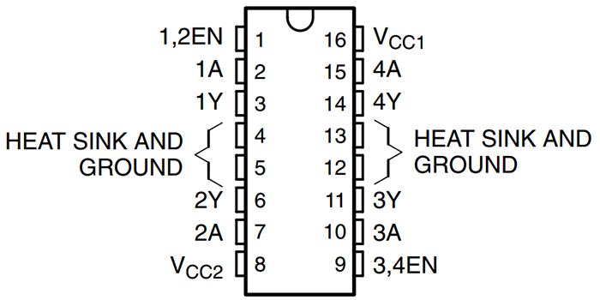Adding components
           1. Adding the L293D

With the slot pointed upwards, insert the L293D into the holes on the board in section E of the Component Locations image.

It may be necessary to *slightly* bend the pins inward in order to easily insert the L293D into the board.

Solder each pin into place.

* + - * 1. Adding the 0.1uF capacitors (optional)

Simply solder the capacitors into the holes for C1 & C2. Orientation does not matter.

C1 is located to the bottom-left of the L293D, slightly left of the 12V power input.

C2 is located directly above the L293D.

* + 1. For populated board-Change JST connector instructions for dosing
       1. Wiring from Leviathan to your dosing pump(s) connector
          1. When measuring & cutting the wiring to the jacks, leave enough wire to span from the board connection to your enclosure’s dosing control jack’s hole.
          2. The following instructions will refer to the wire colors as red & black. Substitute your wire color in place of the specific color called for if desired.
          3. If you are using 2 dosing pumps, you will need 2 sets of red/black wire, or a cable with 4 separate wires.
          4. Refer to the labeling/documentation for your jack to ensure you solder to the correct tabs. You can determine this by connecting the male & female connectors together, then using a multimeter to determine which tabs have conductivity across them.
          5. For ease of documentation, the tabs will be referred to in the following manner:

Tab 1- Dosing pump #1 terminal 1

Tab 2-Dosing pump #1 terminal 2

Tab 3-Dosing pump #2 terminal 3

Tab 4- Dosing pump #2 terminal 4

* + - * 1. Solder your first black wire to tab 1, red wire to tab 2. If using 2 pumps, solder your second black wire to tab 3 & second red wire to tab 4.
        2. Connect or solder your pairs of black & red wires to the connections for dosing pumps, located in section H in the Connector Locations image.
        3. If you are using the JST connectors on the board, crimp your pins onto the end of each wire. With the center key pointed upwards, install them in a connector in the following order from the left: blue, black, green. You may now plug the connector into the board. Need to change this to reflect dosing wires.
        4. If not using JST connectors, with either your pin headers or directly soldering to the board, connect the first black wire to the dosing hole labeled “1”, the first red wire to the dosing hole labeled “2”, the second black wire to the dosing hole labeled “3” & the second red wire to the dosing hole labeled “4”.
        5. Install your female TRS or TRRS connectors into your enclosure.
      1. Connecting the wiring to your dosing pumps
         1. The pump will work whether you connect the red or black wire to the left or right terminal. The difference between the two configurations will be the pump direction.
         2. To standardize the directions for both pumps, it is recommended to solder the black wire to the + terminal of your pump & the red wire to the opposite terminal. Either way, ensure you wire both pumps the same way if you are using two, to prevent confusion during configuration.
         3. Cut lengths of your red/black wire or cable long enough to reach between your dosing connector & your actual dosing pumps.
         4. Strip approximately ½” off the ends of each wire.
         5. There are two methods for securing the wires to the pumps. Soldering & spade connectors.
         6. The easiest & recommended way to attach to the pumps is with female “spade connectors”. This allows for quick connection & disconnection.

Simply crimp your wire into the connector, then slide the connector onto the correct terminal of the pump.

If you used this method, you may skip step 5, the following step.

* + - * 1. Another way of connecting to the pump is with soldering & heat shrink.

Slide a small piece of heat shrink onto each of your wires.

Leave enough of a spacing between the end of the wires & the heat shrink to prevent the heat shrink from being heated while you solder the wires to the pump terminals.

Solder the wires to the correct terminals.

Slide the heat shrink down over the soldered connection.

Heat the heat shrink with a heat gun or other method to shrink it down tightly.

* + - 1. Connecting your dosing pumps to Leviathan
         1. The wiring from your pumps will attach to your male TRS or TRRS connector.
         2. Refer to your connector’s documentation to determine which tabs to solder to. You can also determine this on your own using a multimeter. For naming sake:

Tab 1- connected to tab 1 of female connector

Tab 2-connected to tab 2 of the female connector

Tab 3-connected to tab 3 of female connector

Tab 4- connected to tab 4 of female connector

* + - * 1. From pump #1- solder the black wire coming from the + terminal to tab 1, red wire to tab 2. From pump #2- solder the black wire coming from the + terminal to tab 3, red wire to tab 4.
        2. You can now plug this male connector into your female dosing pump connector.

## Float Switch(es)

1. Components required
   * + 1. Float switch(es)
          1. Leviathan can utilize mechanical float switches to detect when the water level has dropped below the desired level due to evaporation or other means.
          2. The recommended & tested float switch is the DP5200 from Anndason. However, it is likely any simple float switch will work.
       2. 1206 surface mount (SMT) resistors
          1. Each float switch uses a 10k ohm resistor.
       3. 2-pin JST-XH connectors (optional)
          1. 2.5mm JST-XH connectors are recommended to connect the float switch(es) to the board.
          2. You may use pin headers & jumpers in their place, or solder directly to the board if desired.
       4. Mounting bracket(s) (optional)
          1. Along with this documentation, you should have received 3D object files. Among these files, you will find the float switch brackets.
          2. If you want to print your own, first open the files in your slicer.
          3. Slice the model for the bracket(s) you wish to print.
          4. Look up instructions for your slicer on how to add a pause in your G-code.
          5. Add the pause right before the top layer of the hollow cylinder is printed.
          6. When you print this file & it reaches the pause point, drop 2 10x2mm neodymium magnets into each cylinder.
          7. Resume the print, enclosing the magnets.
     1. Populating the board
        1. Adding connectors
           1. Connectors for each float switch are labeled FSW 1 or 2 & are located in the center of Leviathan, section J of the Connector Locations image.
           2. Simply solder on the same number of 2 pin header sets or 2-pin JST connectors as float switches you plan on using, matching the footprint printed on the board.
        2. Adding resistors
           1. Each float switch uses a single 10k ohm resistor.
           2. Float switch 1 uses R3 & float switch 2 uses R2.
           3. Solder each resistor into place for each float switch you plan on using.
     2. For populated board
        1. Wiring the float switch(es)
           1. Most float switches have short wires. If this length works for you, skip to step 6. Otherwise, proceed through the instructions to extend your float switch’s wire length.
           2. Any wire 24 gauge or larger can be used to extend the float switch wires. It does not matter what color, or which hole on the float switch connections you use. To re-use additional wire, it is recommended to use the low voltage red & black cable mentioned in the dosing module if you utilized this module.
           3. Simply strip a small amount off both ends of your extension wires, as well as the ends of the wires coming from the float switch.
           4. Solder one extension wire to one wire from the float switch, then the other extension wire to the other wire from the float switch.
           5. Slide heat shrink onto the extension wire & place it around the new solder joint. Heat it to shrink & protect the joint.
           6. Feed the wire through the float switch cable opening in your enclosure if applicable.
           7. Using the exposed, stripped end of your wires coming from the float switch, attach one wire to the left hole of float switch 1 & the other wire to the right hole of float switch one. Order does not matter.
           8. Repeat this process for float switch 2 if desired.
        2. Mounting the float switch(es)
           1. If you are using brackets you received in a Leviathan package, simply place the threaded section of the float switch into the clip & screw the nut on the float switch down tightly to hold it in place.
           2. If you printed your own brackets, you’ll have to glue the clip into the magnetic brackets, then attach the float switch using step 1 above.

## Optical Sensor(s)

1. Components required
   * + 1. Optical level sensor(s)
          1. Leviathan can utilize optical level sensors to detect when the water level has dropped below the desired level due to evaporation or other means.
          2. Recommended optical sensor is from DFRobot. No other sensor has been tested or is likely to work with leviathan.
       2. 2-pin JST-XH connectors (optional)
          1. 2.5mm JST-XH connectors are recommended to connect the optical sensor(s) to the board.
          2. You may use pin headers & jumpers in their place, or solder directly to the board if desired.
       3. Mounting bracket (optional)
          1. Along with this documentation, you should have received 3D object files. Among these files, you will find the optical sensor brackets.
          2. If you want to print your own, first open the files in your slicer.
          3. Slice the model for the bracket(s) you wish to print.
          4. Look up instructions for your slicer on how to add a pause in your G-code.
          5. Add the pause right before the top layer of the hollow cylinder is printed.
          6. When you print this file & it reaches the pause point, drop 2 10x2mm neodymium magnets into each cylinder.
          7. Resume the print, enclosing the magnets.
     1. Populating the board
        1. Adding connectors
           1. Connectors for each optical level sensor are labeled OPT 1 or 2 & are located in the center of Leviathan, section K of the Connector Locations image.
           2. Simply solder on the same number of 3 pin header sets or 3 pin-JST connectors as optical level sensors you plan on using, matching the footprints printed on the board.
     2. For populated board
        1. Wiring the optical sensor(s)
           1. The DFRobot optical level sensor has a relatively short connecting cable. If this length works for you, skip to step 6. Otherwise, proceed through the instructions to extend your sensor’s cable length.
           2. Any wire 24 gauge or larger can be used to extend the optical sensor’s wires. It does not matter what color, or which hole on the float switch connections you use. For ease of keeping track, it is recommended to use the same color wire as the wire you are extending. These instructions will follow this method.
           3. Simply strip a small amount off both ends of your extension wires, as well as the ends of the wires coming from the optical sensor. Add specific instructions for optical sensor w/ stripping the heat shrink jacket.
           4. Solder your extension wires one by one to the wires from the optical sensor.
           5. Slide heat shrink onto the extension wire & place it around the new solder joint. Heat it to shrink & protect the joint.
           6. Feed the wire through the optical sensor cable opening in your enclosure if applicable.
           7. Using the exposed, stripped end of your wires coming from the optical sensor, attach list colors & what holes they go to.
           8. Repeat this process for optical sensor 2 if desired.
        2. Mounting the optical level sensor(s)
           1. If you are using brackets you received in a Leviathan package, simply place the threaded section of the optical sensor into the clip & screw the nut on the optical level sensor down tightly to hold it in place.
           2. If you printed your own brackets, you’ll have to glue the clip into the magnetic brackets, then attach the optical level sensor using step 1 above.

## pH Probe

1. Components required
   * + 1. pH board or circuit/plug
          1. It is recommended to use the pH circuit & connector made by Michael Lane. These can be purchased at: <https://www.tindie.com/products/ranthalion/isolated-ph-probe-interface-for-reef-pi/> . This connector will be covered in the instructions below.
          2. You can also use a combination of the EZO pH circuit & a BNC connector & carrier board. However, this is double the price & requires more work. If you prefer to go this route, refer to the Adafruit Reef-Pi guide for setup instructions.
       2. pH probe
          1. The following probes have been confirmed to work with Leviathan: American Marine Pinpoint, Atlas Scientific, BRS Double Junction, & Milwaukee ma913b/3. Any double junction pH sensor with a BNC connector should work, but is not guaranteed outside of this list.
     1. Populating the board
        1. Adding connector
           1. The connecting point for the pH probe is labeled pH Probe & are located near the center of Leviathan, section L of the Connector Locations image.
           2. Simply solder on the 4 pin headers or 4-pin connector matching the footprint printed on the board.
     2. For populated board
        1. Wiring from the connector to the board
        2. Addressing the pH probe

# Operation

## Adding the Raspberry Pi

* + 1. Downloading the files
       1. From email
          1. Everyone who purchased a Leviathan board or package via Kickstarter should have received an email titled “Leviathan Instructions & Files”.
          2. Simply download the attached folder named “Leviathan Files” to your computer’s downloads folder.
       2. From GitHub
    2. Preparing your Micro SD card
       1. Insert your Micro SD card into your computer or SD card reader.
       2. Open a window to show your SD card’s contents.
       3. Format as FAT32. If you are unsure how to do this, typically you just right click the SD card icon/name, select format, then make sure the format is selected as FAT32. If this does not work, you may have to search for instructions on your specific operating system.
       4. From your downloads folder (or wherever you chose to download the files), unzip the folder named “Leviathan Files”.
       5. Once unzipped & opened, you’ll see a long list of files in this folder. Simply copy & paste them onto your SD card.
       6. Now insert the SD card into your Raspberry Pi.
    3. Powering
       1. DIY build
          1. Pin Headers

It is recommended to add female pin headers to the Leviathan board in order to easily add & remove your Raspberry Pi.

Solder the pin headers with the male end entering the board from the back side. Looking at the front of the board with the Leviathan logo, you should just see the metal tips of the female pin headers.

If you do not use pin headers, you may solder the Pi directly to Leviathan, though this is not advised. If you have to correct anything or change Pis, you’ll either have to undergo extensive de-soldering or just buy a new Leviathan board.

* + - * 1. Checking your voltage

It is highly recommended to check the voltage coming from your Leviathan board before plugging in your Raspberry Pi. Failure to do so may result in a dead Pi.

Plug in your 12V power adapter to the wall, then into your 2.1mm barrel jack. If you do not have this set up, refer back to Section 7.1 to correctly set up your power.

With a multimeter, ensure the top-right pin is outputting 5V.

If it is not, refer back to Section 7.1 to correctly set up your power connections & components.

* + - * 1. Plugging in your Pi

**Important note**-Do not touch the back of your Raspberry Pi where the pin headers are soldered on. Doing this while they are powered can easily cause shorted connections, which will kill inputs or the entire Pi itself. Personally, I place a small piece of electrical tape over these anytime I handle the Pi.

Holding your Raspberry Pi by the edges, plug it into the pin headers on the back of Leviathan.

Unless you soldered them perfectly straight, it may take a bit of force or wiggling to get the Raspberry Pi in. Do not press so hard the board or Pi start to flex.

You may press on the back of the Pi to get it into the headers, as long as you do not touch any of the metal connections or solder points on the Pi.

* + - 1. Package
         1. **Important note**- Do not touch the back of your Raspberry Pi where the pin headers are soldered on. Doing this while they are powered can easily cause shorted connections, which will kill inputs or the entire Pi itself. Personally, I place a small piece of electrical tape over these anytime I handle the Pi.
         2. If you are not using the Raspberry Pi Zero W, you will have to punch out the slot in front of the enclosure. If you line up your Pi with the rectangular pin headers, you’ll see where the slot lines up with the USB & Ethernet ports.
         3. Plug in your Raspberry Pi into the rectangular connector in the front of your enclosure. This may take a bit of force & wiggling. Do not press so hard as to bend the Raspberry Pi.
         4. Pug your 12V power adapter into the wall, then into the inlet on the back of the enclosure.
         5. Flip to power switch to the | icon, which is the ON position (O is OFF).
    1. Interfacing
       1. Raspberry Pi with standard HDMI & USB ports
          1. Power off your Raspberry Pi if it is on using the power switch, or simply unplugging the 12V adapter.
          2. Plug in your HDMI cord to any input of a TV or computer monitor with HDMI capability.
          3. Plug the other end into your Raspberry Pi’s HDMI port.
          4. Plug in your USB mouse & keyboard. (If using the Zero W with one port & separate mouse/keyboard, start with your mouse.)
          5. Turn the Raspberry Pi back on. Most Pis have a small green LED on the front that will light up, indicating it is receiving power.
          6. You should see something (generally a “rainbow screen” followed by the Raspberry Pi logo) come up on your display, if not, make sure your source input is set correctly, you are receiving power to the Pi, & all your connections are correct.
          7. Allow time for the Raspberry Pi to boot up (typically less than 1 minute) & you should be presented with your desktop!
       2. Raspberry Pi Zero W
          1. You will need to use a micro HDMI adapter & micro USB adaptor to plug in your HDMI cord & usb dongle/mouse/keyboard. After adding the adapter, follow the steps for section a. above, “Raspberry Pi with standard HDMI & USB ports”.
       3. Raspberry Pi 4
          1. You will need to use a micro HDMI adapter to plug in your HDMI cord. After adding the adapter, follow the steps for section a above, “Raspberry Pi with standard HDMI & USB ports”.
    2. Setting up Wi-Fi
       1. Click the Wi-Fi icon in the top right of your screen.
          1. Depending on whether the Pi auto-connected to a network around you, it may appear as the typical sound-wave icon, or as 2 bars with red x’s.
          2. If your Wi-Fi is off, turn it on by clicking Turn on Wi-Fi in the box that pops up when you click the icon, then click the Wi-Fi icon again.
       2. Select your Wi-Fi network from the list you are presented.
       3. Type in your password in the “Pre Shared Key” box & click OK.
    3. SSH Access (optional)

## Setting Up Reef-Pi

1. Accessing Reef-Pi for the first time
   * + 1. Logging in
          1. Open your web browser by clicking the globe icon in the top left of the screen, next to the Raspberry Pi icon.

If you are using a Zero W, this may take a minute or so to load.

* + - * 1. In the address bar, enter the following address & press enter: <http://Leviathan.local>
        2. Once this page loads, you’ll be presented with the Reef-Pi sign in screen. The default username & password is: reef-pi.

You can change this later in the configuration options. I highly recommend it-do you *really* want an unsecure default password being the only thing standing between your aquarium & anyone with access to your network?

* + - * 1. Click the green Sign In button after entering reef-pi into both the username & password boxes.
      1. The dashboard
         1. You’ll be presented with your default dashboard. You can change the modules shown later in the configuration section.
         2. This will be the “main display” of your control system if you choose to use a dedicated tablet for your tank control.
      2. Navigating Reef-Pi
         1. Depending on your screen size, you will see one of two things in the green bar along the top of the screen: Names of modules (like “Equipment, timers, etc.) or an expanding menu button (3 white lines).
         2. If you see the names, you can simply click each to get to the module’s individual pages & settings.
         3. If you see the expanding menu button, click it to access the list of module names. From here, you can click each to get to the modules individual pages & settings.

1. Configuring Reef-Pi
2. Default configuration (Each package will need its own)
   1. If you received a full Leviathan package, you’ll already have a default configuration set up for your specific package.
   2. If you received a populated Leviathan board, you’ll already have a default configuration set up for the most advanced version of your board’s capabilities.
   3. If you received a bare Leviathan board, you will not have a default configuration. Since I can’t predict what modules you’ll be adding, it wouldn’t make sense to have features enabled that you aren’t using, resulting in error messages & blank spaces in your dash board.
3. Making changes to your configuration
   1. Navigate to the “Configuration” screen from your menu bar on top of the screen.
   2. From this screen, you can make changes to your Reef-Pi setup.
   3. It is recommended to change Authentication- Enter a new username & password. Ensure you write this down somewhere secure, as forgetting them will require you to re-install from scratch.
   4. Insert note about enabling or disabling modules based on your setup.
   5. For any assistance with any changes not covered in the below sections you wish to make, refer to the Reef-Pi configuration & Installation guide on Adafruit.
4. Dashboard
   1. You can easily change the information displayed on your dashboard to reflect your personal preferences.
   2. Navigate to the dashboard & click the Configure button in the bottom right.
   3. You’ll be brought to the configuration screen & presented with options to change your dashboard size, layout, & charts.
   4. You can change the number of rows & columns displayed on the dashboard by changing the numbers in each of the first boxes.
   5. You can change the width & height of the dashboard by changing the numbers in the second set of boxes.
   6. You can change the information displayed in these rows & columns by clicking gray boxes. For example, if you want to change the top right box to display your tank’s temperature graph, take the following steps:
      1. Click the top gray box with a module name (doser, health, ato, etc…) in the top right box.
      2. From the drop down list, select temperature.
      3. Click the second gray box below the module.
      4. You’ll be presented with a dropdown list of specific temperature sensors. Select the one monitoring your tank.
   7. Once you are satisfied with your configuration, click the Update button in the bottom right of the screen. It will turn green once your changes have been saved.
   8. Once your configuration has been updated, you can click the Back to dashboard button.
5. Inlets, outlets, sensors, jacks, etc.
   1. Navigate to your Configuration screen.
   2. Click the Connectors selection near the top.
6. Equipment
   1. Navigate to your Equipment screen.
   2. If you’re using a default configuration, you’ll see a list of generic equipment names.
   3. You can edit these generic names by clicking the edit button on the right of the screen.
   4. In edit mode, you can change the name of the equipment, as well as the outlet it is associated with.
   5. If you are using a package, outlets are numbered like you’d read a book: Top left most-outlet is #1 & bottom right-most outlet is the last number.
7. Temperature
   1. Navigate to your Temperature screen
8. Dosing
   1. Navigate to your Dosing screen
9. Auto Top-Off (ATO)
   1. Navigate to your ATO screen
10. Lights
    1. Navigate to your Lights screen
11. Macros
    1. Navigate to your Macros screen
12. Timers
    1. Navigate to your Timers screen
13. Troubleshooting & additional resources

## Using Reef-Pi

1. Equipment
   * + - 1. Adding new equipment
         2. Using your equipment
2. Temperature
   * + - 1. Adding new temperature probes
         2. Controlling equipment with temperature probes
3. Dosing
   * + - 1. Adding new dosing pumps
         2. Calibrating your dosing pumps
4. Auto Top-Off (ATO)
   * + - 1. Adding new float switch
         2. Adding new optical level sensor
         3. Setting up your ATO pump
5. Lights
   * + - 1. Adding new lights
         2. Manual light control
         3. Automatic light control
6. Macros
   * + - 1. Creating a new macro
         2. Running macros
7. Timers
   * + - 1. Creating a new timer
8. Troubleshooting & additional info
   * + - 1. xyz
         2. xyz

# Miscellaneous Notes

## Current draw

1. Typical mA values based off data from <https://www.raspberrypi.org/documentation/faqs/>. Peak mA value comes from the average value for a stressed a Raspberry Pi 3B connected to a HDMI monitor, USB keyboard, usb mouse, & Wi-Fi. Typical mA value comes from the average value for a Raspberry Pi 3B performing video playback.
2. In the case of a Raspberry Pi connected to Leviathan, no USB peripherals are being used, therefore actual mA draw should be much lower. However, it is recommended to provide a power supply rated for at least 2.5A in order to allow for peaks in power consumption.
3. Estimating power draw of your equipment.
   * + 1. Note-this is a very rough estimate, based on figures from First Choice Power & a 30 gallon tank, reported current draws for forum users’ tanks, as well as some equipment from my own tank.
       2. It is highly recommended to refer to your equipment’s manufacturer or user manual to find the actual power draw for your specific device.
       3. A Leviathan package is rated to handle up to 10 Amps. Any higher power draw may lead to damage to the system, your equipment, or your property.

If your device gives a wattage rating, divide watts by the power to your system. (e.g. 165 W LED fixture running on typical 120V power from wall is 165/120=1.375 Amps

Heater=1.25 Amps

Return pump=0.2 Amps

Mid-size LED Light Fixture=1 Amp

Protein Skimmer=0.5 Amps

UV Lamp=0.05 Amps

T8 Fluorescent bulbs =0.2 amps

To visualize a typical reef tank’s power consumption, my tank’s stats are as follows:

|  |  |
| --- | --- |
| **Equipment** | **Peak Power Draw (A)** |
| Return Pump | 0.25 |
| Tank Heater | 1.25 |
| Sump Heater | 0.67 |
| Leviathan | 2.25 |
| Power Heads | 2.2 |
| 165 W LED Lights (x2) | 2 |
| Protein Skimmer | 0.5 |

This is a total peak current draw of 9.12 amps. Keep in mind, peak current draw tends to be much higher than actual current draw. Based on my research through forums of people reporting their tank’s actual current draw, it tends to be between 2.5 to 5 amps.

# Troubleshooting

# Links (Updated manual, setup files, 3D printable files, etc.)